Krono Battle System:
Turn based battle system with a time twist. Chronological powers distort the time flow of battle for both enemy and party members enabling for an interesting combat system.

Terms/powers
*Powers can be used both on enemy and ally at any instant during combat.

FastForward(FF): Increase speed of actions
Combat Ex: character takes up whole action bar to perform 3 attacks. While FF is being used onto character can now perform 5 single attacks in 1 action bar

Reverse(Rv): Rewinds target’s actions
Combat Ex: Player attacks enemy with a slash dealing 255 dmg. Use Reverse power to rewind the character animation thus taking back dmg dealt. Let go of Reverse power attack sequence takes place again however dmg is recalculated going either higher or lower than the original dmg. Could even cause a critical hit. Reverse power could also be used long enough to change the action, say the enemy absorbed the attack, reverse power to the point where player chooses the character action.

Pause(P): Freezes target’s current action/animation. Resumes after released
Combat Ex: Enemy moves to player about to attack, Use Pause power, enemy is now frozen, allowing the next person to attack. With the enemy closer character has more action time to perform attacks/combo instead of wasting it on moving towards the enemy.

Stop(S): Stops target’s turn. Target’s turn resumes after 1 enemy/ally has performed action.
Combat Ex: Enemy has been charging a strong attack, on the turn that the enemy is supposed to unleash attack, use Stop power to move enemy turn over, allowing player to attack or defend before enemy turn resumes and does charge attack.

Skip(Sk): Ignore Target’s turn, Action bar restarts at 0
Combat Ex: Enemy is next up to take action, use Skip power to restart its action bar to zero. Ally is confused ailment about to attack self, use skip power on ally so player has a chance to cure status ailment.

Repeat(Rp): Replay Target’s turn. Includes same damage/healing dealt
Combat Ex: Player uses omislash on enemy, at anytime during the attack or after turn is finish, use replay power, after current turn is finished, character will perform the same actions (healing,attacks etc) again dealing the same amount of damage dealt as before.

Advance Frame(Af): skips animation every 3 frames. Any healing/attacking within the frame is unblock able or dodgeble.
Combat Ex: Player fighting against enemy known to dodge or counter almost all attacks. Use Af right before attack physically hits to deal direct damage to enemy.

Revert Frame(Rf): Rewinds animation every 3 frames.
Combat Ex: say an any enemy has attacked you and that character dies, use Rf to do a quick rewind and try to block or counter the attack. (counter attacks explain later)

Restart(Rs): start over target’s turn to the point of choosing actions
Combat Ex: character attacks enemy but enemy is invulnerable to that type of attack, use Restart power so player can choose a different action.

Slow(Sl): Lowers speed of targets action, X2 damage but easier to block/counter
Combat Ex: character about to do final attack, use Sl power to increase possible dmg onto enemy. Enemy about to attack use Slow power so player has easier to block/counter/dodge attack.

*Having Time control powers can be very overpowering and make the game easier so some sort of constraints will be needed. Such as A “Time Power Bar” that charges each time a player attack. Each power depletes the bar at different rates, powers like Fastforward or Slow depletes at a constant rate while power is being used. Powers like Restart and Advance Frame depletes in chunks or whole bars.
*Counter/Blocking/Dodging somewhat similar to Legend of Dragoon, where GUI on screen shows up and if player presses button at right time player is able to C/B/D. Characters can do any of the following depending on their equipment. Heavy armors can only block, Lighter armors can dodge, medium armors can counter etc.
* Some powers have the same effect as others (Stop, Skip) these powers could be either exclusive to the character, to allow a mix and match of party member power combos, OR they could be a way to increase the level of the Time Powers into stronger uses. Ie: Stop levels up to Skip.

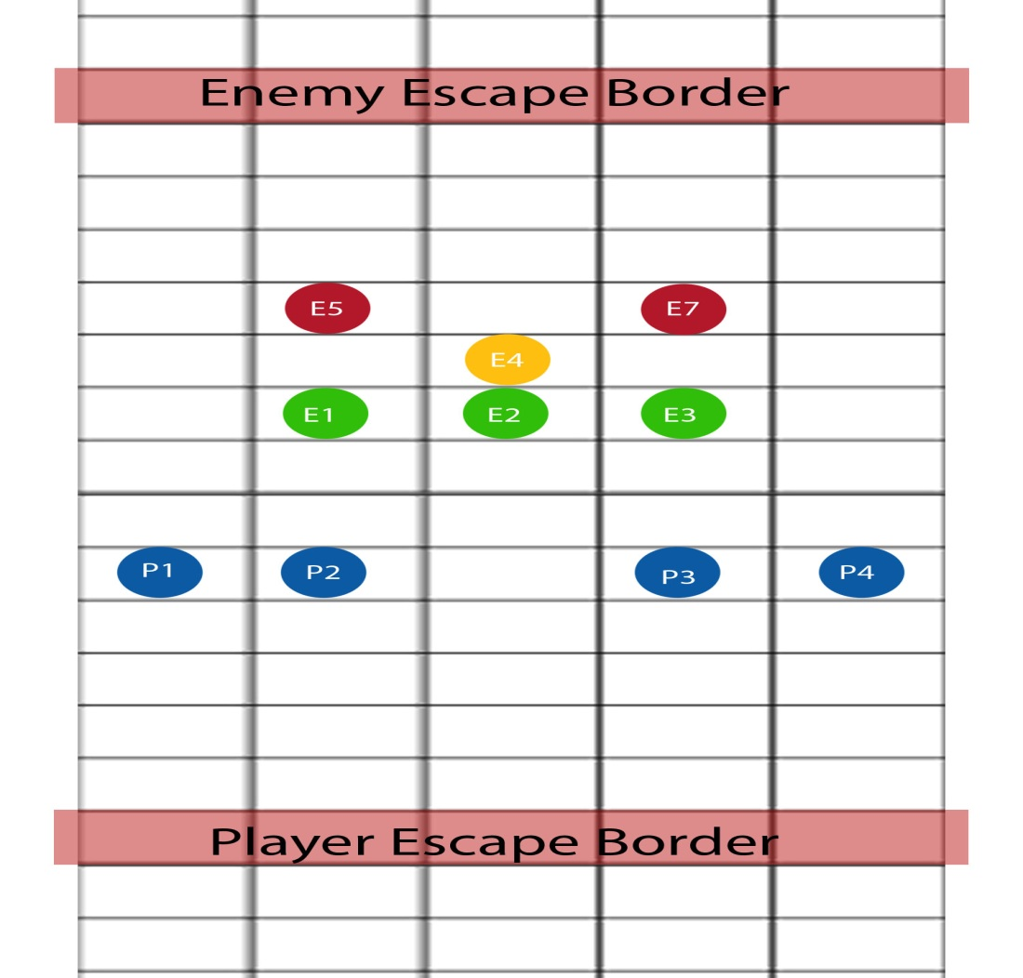
Here is a quick top view of what the battle could look like.
-Players(blue) can only attack enemies of the first layer(green). Until the first layer is cleared 2nd/3rd layer (yellow/red) cannot be targeted unless with far range weapon that can reach over ie: long Bow.
--Alternate way to attack E4, P1 does a combo on E2 that end with E2 into the air. Someone uses Pause power E2 will stay suspended into the air till power is release. At that time player can attack E4 because no enemy or building is in the way of attacks.
--Senario1: player eliminated Green layer, no E4,E5,E7 are left. In most cases where monsters are more stronger/smarter are placed beyond the 1st layer. If player tries to attack E5 or E7 with a close encounter attack (ex:sword Slash) E4 will more likely try to cancel that attack by either jumping in the way and bouncing the player back, or attack the player when player has reached the enemy.
--Senario2: If player cannot reach enemy or enemy trying to escape player may expend 1 action bar to move whole team or single person a layer up.
--Senario3: there may be cases where buildings or pillars are in the line of sight, if object is in the way player must destroy the object that is blocking attack path.
--Senario4: If battles go on for a long time, more enemies will join in the fight, and can enter from either side of the battle field.

-Misc Ideas:
If game uses Time Battle system, Real time could affect the characters in combat. Say the 4 characters have an affinity to times 12, 3, 6, 9 o’clock. And say the player enters a battle at 9 o oclock in the morning, the character that has that time of day connection will get a status buff or bonus exp or something of that nature.
Player can find other people (that have time powers) to add to party, however if the deal turns sour or optional character decided to fight player, if player kills another time controller, it affects the Hour that optional character has affinity to. Example player Kills person with affinity to 8pm. If player plays 8am nothing changes but at 8pm battles are more harder with enemies gaining defense boosts.
Time shards fly throughout galaxy, some directly into animals/monsters, which grants them some control over time as well. Some areas are affected by “Time Distortion pollution”
Characters will have a regenerating shield (Halo) that gets dealt damage first (unless attack ignores shield) body Shield regenerates at the end of battle. If shield is depleted character will begin to take real damage, If Health reaches 0 character dies. Character can be revived but with no shield.

